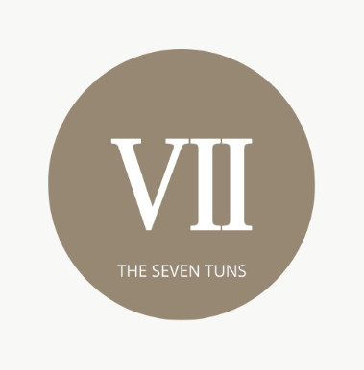
The Seven Tuns
Available Sunday from 6pm-Thursday 8.30pm
£15 for 2 courses

Receive 20% of any wines on our list, both by bottle or glass with any substantial meal

Seasonal soup with homemade bread (Ask your server) (Gl)
Chilli (So, S, Sd) or salt and pepper chicken wings (6 pcs)
Smoked mackerel pate with cucumber and homemade bread (F, Gl, Sd, La)

-----------------------------------------------oOo-----------------------------------------------

Home smoked haddock, salmon and cod pie with sprouting broccoli (F, La, Sd, Gl, Mu)
Pan fried local pheasant with mashed potatoes, winter greens and peppercorn sauce ( La, Sd,)
Roast beetroot with sprouting broccoli ,lentils and tahini dressing (Sd, So, S)(v)

Sandwiches are available at lunch times Mon to Fri, please speak to a member of staff.
A discretionary 12.5% service charge will be added to tables ordering food

Allergen code: Gl– Gluten, C– Crustaceans, E– Egg, N– Nuts, Pe, Peanuts, La– Lactose, Ce– Celery,
Mu– Mustard, S– Sesame, Sd– Sulphur Dioxide, Lu– Lupin, Mo– Moluscs, F– Fish, So– Soya

